A hospital needs to assign 3 doctors (D1, D2, D3) to 3 shifts (Morning, Afternoon, Night)
such that:
Constraints:
i. D1 cannot work Night shift
ii. D2 must work before D3 (Morning &lt; Afternoon &lt; Night)
iii. Only one doctor per shift
iv. D3 cannot work Morning
v. All doctors must be assigned exactly one shift
Apply Backtracking Search to find a valid assignment with all intermediate steps and
constraint checks. State the final valid schedule

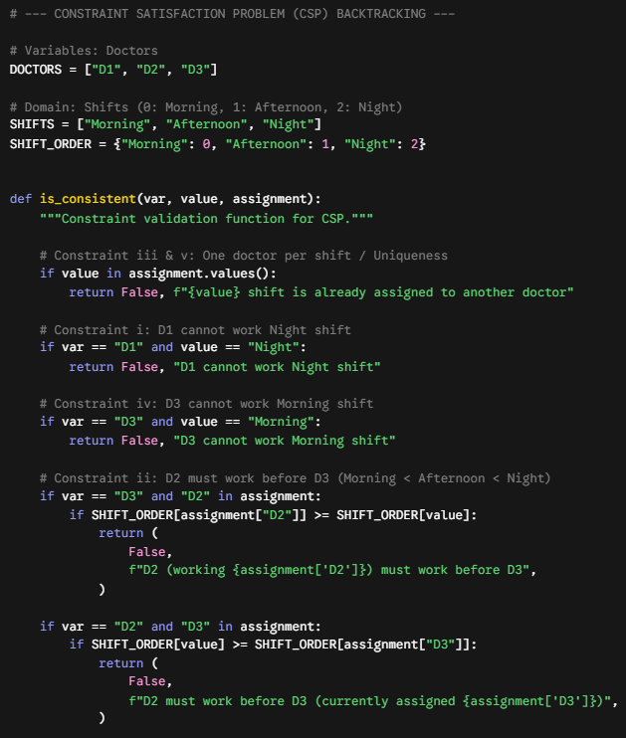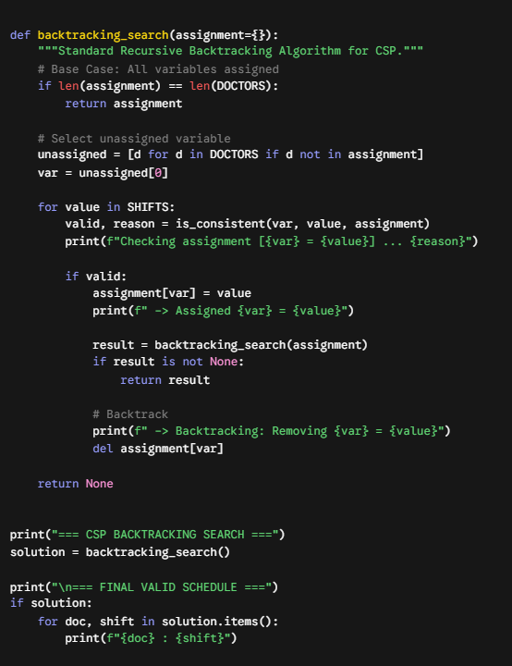
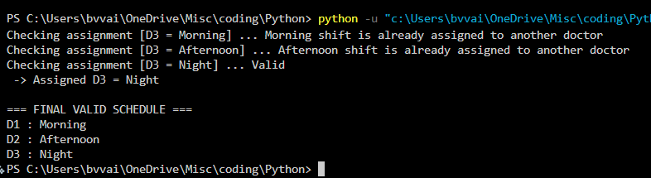
A robot operates in a grid environment (5×5). It must move from Start (S) to Goal (G).
Obstacles block certain paths.
Constraints:
i. Movement allowed: Up, Down, Left, Right
ii. Cost of each move = 1
iii. Cannot pass through obstacles
iv. Use Manhattan Distance heuristic
Using above constraints and BFS Search Algorithm Show step-by-step node expansion
and priority queue updates and determine the optimal path and cost.
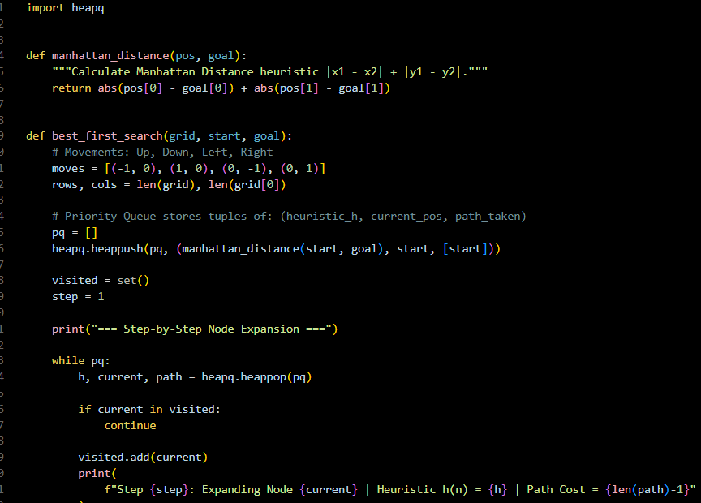
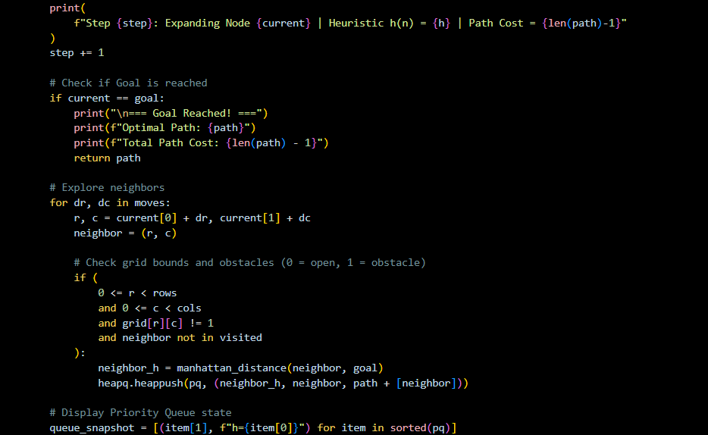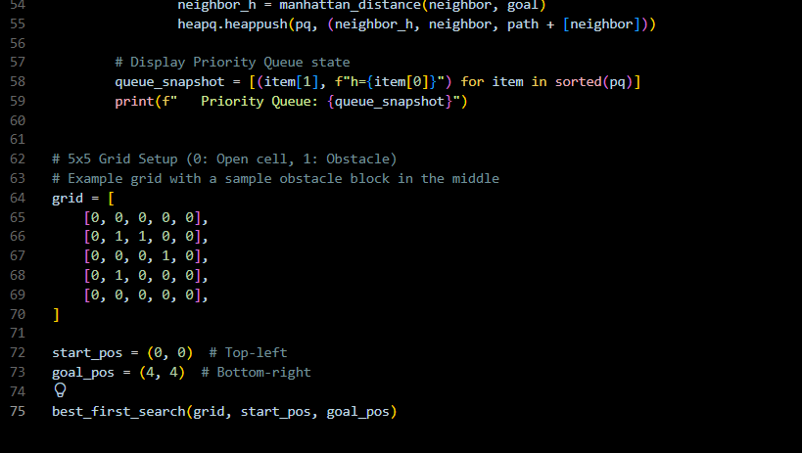
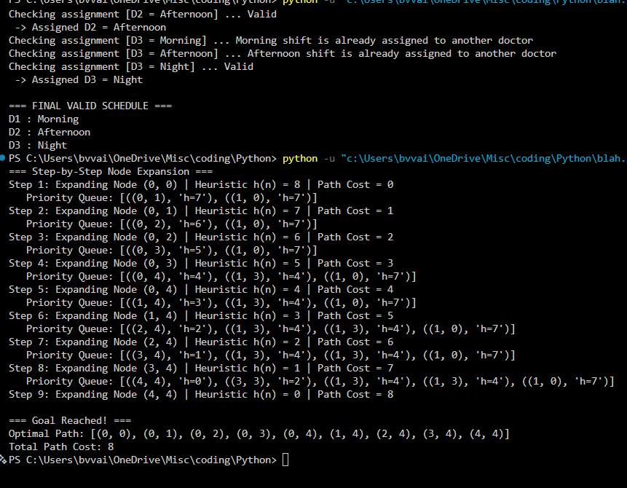
3. An autonomous rescue robot is deployed in a disaster-affected building to locate and
rescue survivors. The robot operates in a partially observable environment where some
paths are blocked, and it must make decisions with limited information.
The building is represented as a grid of rooms. The robot starts at position S and must reach a
survivor located at G.
Constraints:
• The robot can move up, down, left, right
• Some cells are blocked (obstacles) and cannot be traversed
• The robot has limited sensing capability (can only observe adjacent cells)
• Each movement has a cost of 1, but entering risky zones has an additional cost of 2
• The robot must minimize total cost while ensuring safe navigation
• The robot must update its knowledge dynamically (online search scenario)
Tasks:
a) Analyze all the given constraints and explain how they affect the robot’s decision-making
process.

b) Develop a solution approach using an appropriate search strategy (e.g., Uniform Cost
Search / Online Search Agent). Clearly explain the steps involved.
c) Demonstrate how the robot applies AI concepts such as:
• Intelligent agents
• Rationality
• Environment type
d) Justify why your chosen approach is the most suitable for solving this problem under the
given constraints.

Here is a structured, complete, and easy-to-read answer for Question 3, strictly mapped to the Online Search Agent and Searching Techniques concepts from Unit II of your AI syllabus.
a) Constraint Analysis & Impact on Decision-Making
- Partially Observable Environment & Adjacent-Only Sensing: The robot cannot compute a full offline path from $S$ to $G$ ahead of time because unobserved rooms could contain unexpected obstacles or hazards. The robot must make interleaved decisions—alternating between local perception, path planning, and movement.
- 4-Way Movement (Up, Down, Left, Right): At any given room, the agent’s decision space is restricted to a branching factor of at most 4 valid actions.
- Cost Structure (Standard = 1, Risky Zone = 3): Standard movement costs 1, but entering a risky zone adds an extra penalty (+2), bringing its total cost to 3. Decision-making cannot rely on step-count alone; it must track cumulative path costs $g\left(n\right)$ to avoid high-risk areas unless they are significantly shorter.
- Dynamic Knowledge Update (Online Search Scenario): The robot maintains a local grid map in memory. As it moves and observes adjacent cells, it dynamically updates its map state (adding discovered walls/risky zones) and recalculates costs on the fly.
b) Solution Approach: Online Search Agent (LRTA* / Dynamic Uniform Cost Search)
Because the agent acts under uncertainty and updates its knowledge dynamically, the ideal strategy is an Online Search Agent using local exploration paired with dynamic path cost evaluation.
Key Steps Involved:
- Perceive Current State: The robot senses its immediate 4-neighboring cells (Up, Down, Left, Right) to detect walls, clear paths, or risky zones.
- Update Map & Knowledge Base: The robot records newly discovered cell properties (e.g., standard cost = 1, risky cost = 3, wall = blocked) into its internal persistent map memory.
- Evaluate Neighbor Costs:
  - For each valid adjacent cell $s'$, calculate $f\left(s'\right)=g\left(s'\right)+h\left(s'\right)$, where $g\left(s'\right)$ is the step cost to enter $s'$, and $h\left(s'\right)$ is the Manhattan distance heuristic from $s'$ to goal $G$.
- Select Action & Move: The agent selects the neighbor $s'$ with the lowest estimated total cost and executes the move.
- Goal Check: If current position = $G$, terminate with success. Otherwise, repeat from Step 1.
- Backtracking / Re-planning: If a path leads to a dead-end (blocked on 3 sides), the agent updates the estimated cost of that node to infinity and backtracks to the best unexplored frontier cell.
c) Demonstration of Core AI Concepts
- Intelligent Agent (PEAS Representation):
  - Performance Measure: Minimize total path cost while safely reaching survivor $G$.
  - Environment: Grid of rooms with obstacles, risky zones, and survivor $G$.
  - Actuators: Motors for 4-directional movement (Up, Down, Left, Right).
  - Sensors: Proximity and hazard sensors to observe the status of adjacent cells.
- Rationality: The robot acts rationally by choosing the action that maximizes its expected performance measure given its current perception sequence and updated map knowledge. It never enters a risky zone if a safe, cost-effective alternative is known.
- Environment Classification:
  - Partially Observable: The robot can only see adjacent cells, not the full grid.
  - Dynamic / Sequential: Current movement decisions directly affect all future states and total accumulation of path costs.
  - Deterministic: Movement actions succeed predictably (moving Right moves the robot exactly one cell Right).
  - Single-Agent: Only the rescue robot operates within the building environment.
d) Justification of Chosen Approach
An Online Search Agent (such as LRTA* or dynamic cost-based local search) is the most suitable strategy for the following reasons:
- Offline Search Failure: Traditional offline algorithms (like standard $A^{*}$ or static Uniform Cost Search) require a complete initial map. In a disaster-affected building, pre-computing a full path leads to failure when unexpected blockages occur.
- Cost-Optimal Safety Balance: By integrating dynamic step costs ($1$ for normal, $3$ for risky) with heuristic estimates, the agent balances physical distance against hazard risk in real time.
- Memory Efficiency: Online search agents store local knowledge as they explore, making them ideal for autonomous hardware with limited memory capacity navigating unknown or dangerous terrain.
